INDIAN SCHOOL AL WADI AL KABIR
TERM 1: Chapter 2 (Book 2)- Cultural Change (GRADE XII)
NOTES AND Q&A

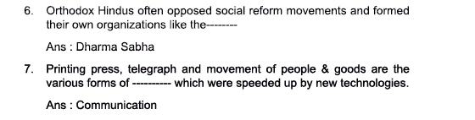
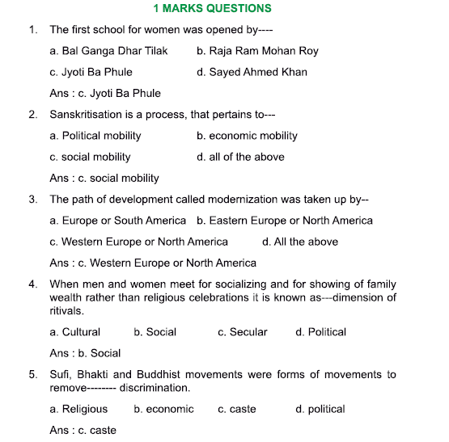
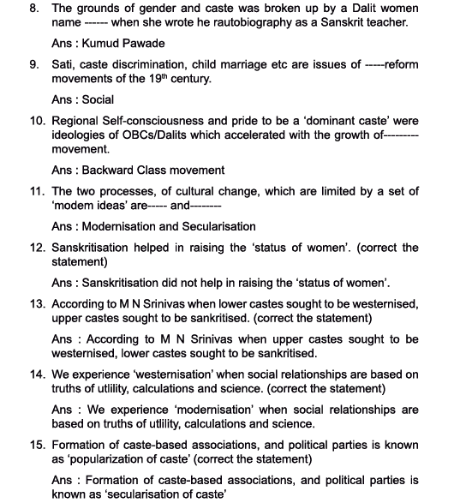
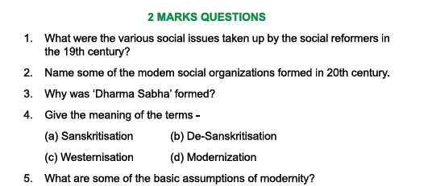
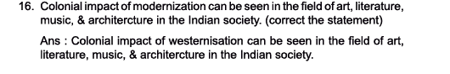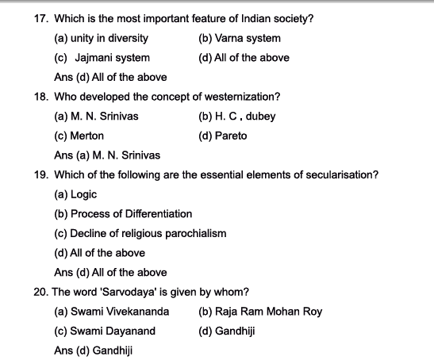
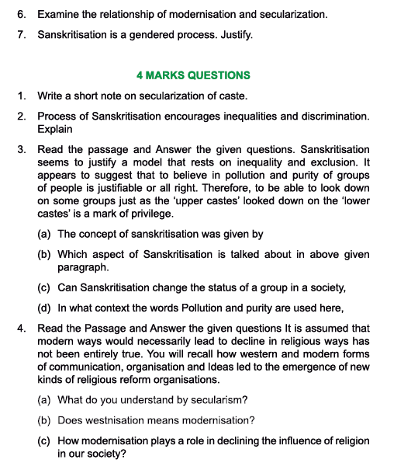
ANSWERS to 2mark questions:
- Various social issues taken up by social reformers: Sati, child marriage, widow remarriage and caste discrimination.
- Modern social organizations: Some of the modern social organizations formed in 20th century were:
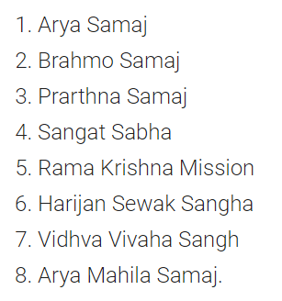
a)Brahmo Samaj in Bengal
b)Arya Samaj in Punjab
c)All India Muslim Ladies Conference

- Why ‘Dharma Sabha’ was formed
The orthodox members of the Hindu community in Bengal formed an organization called Dharma Sabha and petitioned the British arguing that reformers had no right to interpret sacred texts.
- A. Sanskritization
The Term Sanskritization was coined by M.N Srinivas. The process by which a low caste or other group takes over customs, rituals, ideology, beliefs and style of life of a high and in particular, a twice born (Dwija) caste.
b. De-Sanskritization
In regions where the non-Sanskritic castes were dominant, it was their influence that was stronger.
This can be termed the process of de-Sanskritization

c. Westernization: M.N Srinivas defined westernization as "the changes brought about in Indian society and culture as a result of over 150 years of British rule, the term subsuming changes occurring at different levels i.e. technology, institutions, ideology and values".
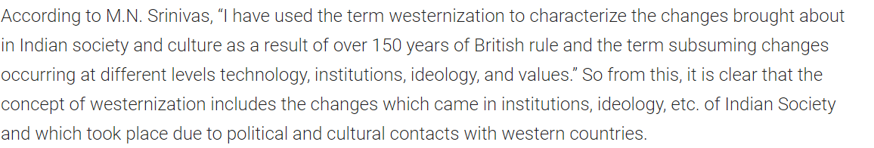
d. modernization

5. Assumptions of modernity
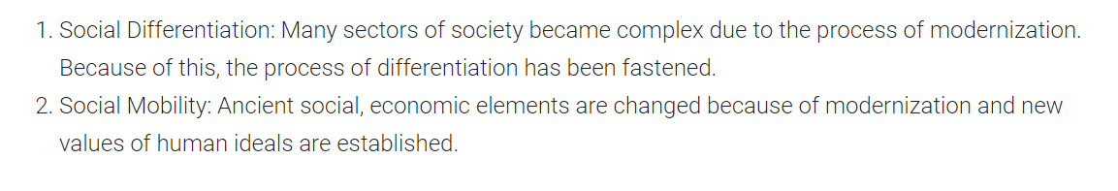
6. Relationship between modernization and secularization
Modernization refers to the improvement in technology, production processes; path of development taken by much of west Europe or north America.
In the west modernization seems to have led to secularization- a process of decline in the influence of religion especially in the public sphere.
Rituals have a secular dimension as it provides occasions to socialize with friends and kin to show off wealth and style to enhance social status.

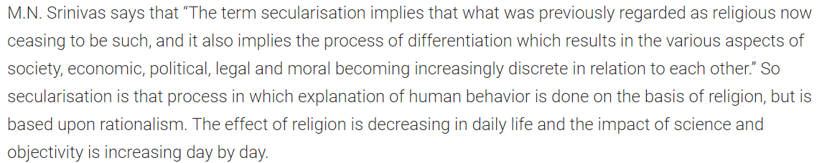
7. Sanskritization is a gendered process-Justify
•Sanskritization supports traditional way of life for women and it is more liberal for modernization or westernization for men.
•Most of the supporters of Sanskritization support the women life within the four walls of the houses. They support or prefer the role of women as a mother, a sister and a daughter.
•They like women to follow the traditional way of marriage with the consent of parents.
Kumud Pawade as a student could enable her to read in the original what the texts have to say about women and the Dalits. As she proceeds with her studies, she meets with varied reactions ranging from surprise to hostility, from guarded acceptance to brutal rejection. As she says “I remember an expression I heard somewhere: “What comes by birth, but can’t be cast off by dying—that is caste?”

Answers to 4-mark questions:
Secularization of caste
In traditional India, caste system operated within the religious framework.
•Belief systems of purity and pollution were central to its practice. India has seen such formation of caste associations and caste based political parties. They seem to press upon the state for their demands.
•Such a changed role of caste has been described as secularization of caste.
•The traditional social system in India was organised around caste structures and caste identities. In dealing with the relationship between caste and politics, however the doctrinaire modernizer suffers from a serious xenophobia.
•Politicians mobilize caste groupings and identities in order to organize their power…. where there are other types of groups and other bases of association, politicians approach them as well. And as they everywhere change the form of such organizations, they change the form of caste as well.
Changes in society brought about by modernization (2 points for 2 marks, the remaining points for 4 marks)
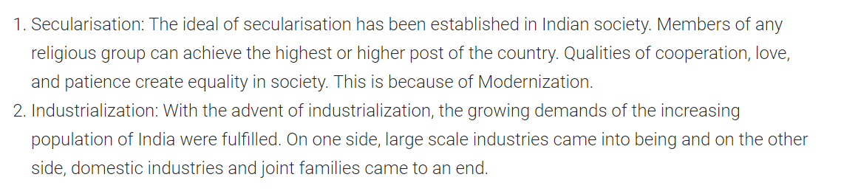
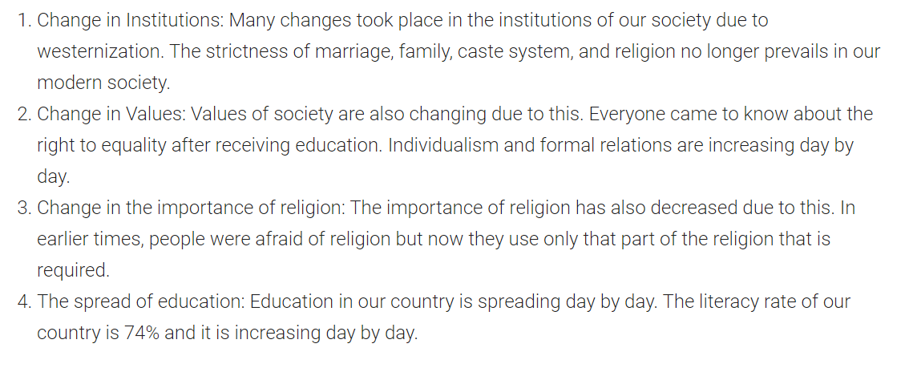
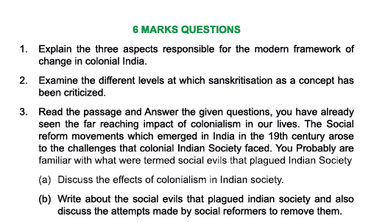
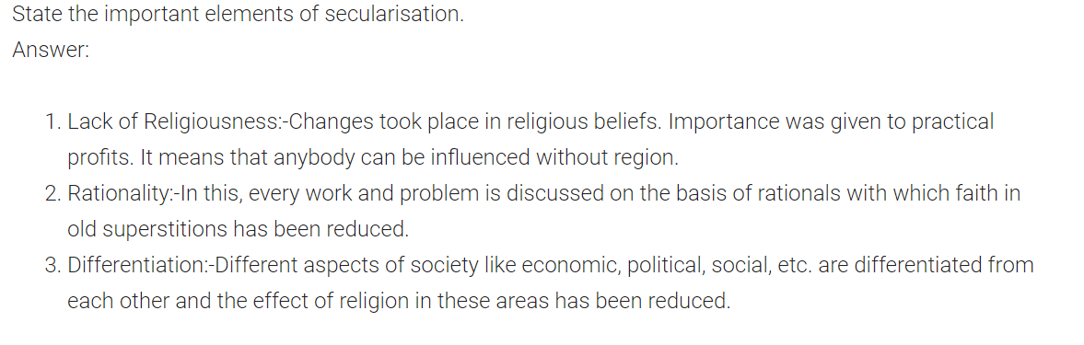
NCERT QUESTIONS:
1.Write a critical essay on Sanskritization.
Ans. •The term ‘sanskritisation’ was coined by M.N. Srinivas. It may be defined as the process by which a low caste or tribe or other group takes over the customs, ritual, beliefs, ideology and style of life of a high and, in particular, a ‘twice-born(dwija) caste’.
•Its influence can be seen in language, literature, ideology, music, dance, drama, style of life and ritual.
•It is primarily a process that takes place in the Hindu space though Srinavas argued that it was visible even in sects and religious groups outside Hinduism.
•It operated differently in different regions. In those areas where a highly sanskritised caste was dominant, the entire region underwent a certain amount of Sanskritisation. In those areas, where non-sanskritic castes were dominant, it was their influence that was stronger, this can be termed as the process of ‘de- sanskritisation’.
•Srinivas argued that, ‘the sanskritisation of a group has usually the effect of improving its position in the local caste hierarchy. It normally presupposes either an improvement in the economic or political position of the group concerned or a higher group self-consciousness resulting from its contact with a source of the ‘Great Tradition’ of Hinduism such as a pilgrim centre or a monastery or a proselytizing sect.”
•But in India, there are many obstacles to any easy taking over of the customs of the higher caste by the lower. Traditionally, the dominant castes punished those low castes, which was audacious enough to attempt it.
•Sanskritisation refers to a process whereby people want to improve their status through adoption of names and customs of culturally high-placed groups. The “reference model’ is usually financially better off. In both, the aspiration to be like the higher placed group occurs only when people become wealthier.
CRITICISMS OF SANSKRITISATION
•It has been criticized for exaggerating social mobility or the scope of lower castes to move up the social ladder. For it leads to no structural change but only positional change of some individuals. Inequality continues to persist though some individuals may be able to improve their position within the unequal structure.
•The ideology of Sanskritization accepts the ways of the upper caste as superior and that of the lower caste as inferior. Thus, the desire to imitate the upper caste is seen as natural and desirable.
•Sanskritization seems to justify a model that rests on inequality and exclusion. It appears to suggest that to believe in pollution and purity of groups of people is justifiable or all right. Therefore, to be able to look down on some groups of people just as the upper caste looked down on the lower castes, is a mark of privilege. It shows how such discriminatory ideas become a way of life. Instead of aspiring for an equal society, the exclusion and discrimination seek to give their own meaning to their excluded status. This gives rise to an undemocratic society.
•Since Sanskritization results in the adoption of upper caste rites and rituals it leads to practices of secluding girls and women, adopting dowry practices instead of bride-price and practising caste-discrimination against other groups. The effect of such a culture is that it erodes characteristics of dalit culture and society. For example, the very worth of labour which lower castes degraded and rendered shameful. Identities based on the basis of work, crafts, artisanal ability are regarded useless.
2. Westernization is often just about adoption of western attire and life style. Are there other aspects to being westernized or is that about modernization? Discuss.
Ans. • M.N. Srinivas defines westernization as “the changes brought about in Indian society and culture as a result of over 150 years of British rule, the term subsuming changes occurring at different levels…. technology, institutions, ideology and values.”
•There were different kinds of westernization:
— One kind refers to the emergence of a westernized sub-cultural pattern through a minority section of Indian who first came in contact with the western culture. This included the sub-culture of Indian intellectuals who not only adopted many cognitive patterns or ways of thinking but also styles of life and supported its expansion,
— There has been a general spread of western cultural traits such as the use of new technology, dress, food and changes in general.
•Westernization does involve the imitation of external forms of culture. It does not necessarily mean that people adopt modern values of democracy and equality.
•Apart from western ways of life and thinking, the west influenced Indian art and literature. The painting of Krishna Menon family in matrilineal community in Kerala but it reflects the very typical patrilineal nuclear family of the modern west consisting of the mother, father and children.
•Srinivas suggested that while lower castes’ sought to be sanskritised the “upper caste’ sought to be westernized. But this generalization is difficult to maintain. For example, the Thiyyas (by no means considered an upper caste) in Kerala show conscious efforts to westernize. Elite Thiyyas appropriated British culture as a move towards a more cosmopolitan life that criticised caste. Also, western education opens up new opportunities for different groups of people.
MODERNISATION
•Modernity assumes that local ties and parochial perspectives give way to universal commitments and cosmopolitan attitudes;
•That the truths of utility, calculation, and science takes precedence over those of the emotions, the sacred, and the non-rational;
•That the individual rather that the group be the primary unit of society and politics;
•That the associations in which men live and work be based on choice and not birth;
•That mastery rather than fatalism orient their attitude toward the material and human environment;
•That the identity be chosen and achieved, not ascribed and affirmed;
•That work be separated from family, residence, and community in bureaucratic organization.
It would be simplistic to state that complex combinations are just a mix of tradition and modernity as though tradition and modernity themselves are fixed entities. Or as though India has or had only one set of traditions. Modernity and tradition are constantly being modified and redefined.
3.Write short notes on:
(a)Rites and secularisation
(b)Caste and secularisation
(c)Gender and sanskritisation
Ans.(a) Rites and secularization:
•It usually means a process of decline in the influence of religion.
•Indicators of secularization have referred to levels of involvement with religious organizations (like church attendance), the social and material influence of religious organization, and the degree to which people hold religious beliefs.
•But the general assumption that modern societies are increasingly becoming secular may not entirely be true.
•A considerable part of ritual in India has direct reference to the pursuit of secular ends.
•Rituals have secular dimensions i.e. they provide men and women occasions for socializing with their peers and superiors.
•They get an opportunity to show off family’s wealth, clothing and jewellery.
•During the last few decades in particular, the economic, political and status dimensions of ritual have become increasingly conspicuous.
(b)Caste and Secularization:
•In traditional India, caste system operated within the religious framework.
•Belief systems of purity and pollution were central to its practice. India has seen such formation of caste associations and caste based political parties. They seem to press upon the state for their demands.
•Such a changed role of caste has been described as secularization of caste.
•The traditional social system in India was organised around caste structures and caste identities. In dealing with the relationship between caste and politics, however the doctrinaire modernizer suffers from a serious xenophobia.
•Politicians mobilize caste groupings and identities in order to organize their power…. where there are other types of groups and other bases of association, politicians approach them as well. And as they everywhere change the form of such organizations, they change the form of caste as well.
(c)Gender and Sanskritization:
•Sanskritization supports traditional way of life for women and it is more liberal for modernization or westernization for men.
•Most of the supporters of Sanskritization support the women life within the four walls of the houses. They support or prefer the role of women as a mother, a sister and a daughter.
•They like women to follow the traditional way of marriage with the consent of parents.
Kumud Pawade as a student could enable her to read in the original what the texts have to say about women and the Dalits. As she proceeds with her studies, she meets with varied reactions ranging from surprise to hostility, from guarded acceptance to brutal rejection. As she says “I remember an expression I heard somewhere: “What comes by birth, but can’t be cast off by by dying—that is caste?”
NOTES:
